|  |
| --- |
| RAWKHIGH |
| My Slot Machine Breakdown |
| **My Slot Machine** |
| Version #1.0  All work Copyright © 2012 by RAWKHIGH.  All rights reserved. |
| **Stephen McArthur** |
|  |

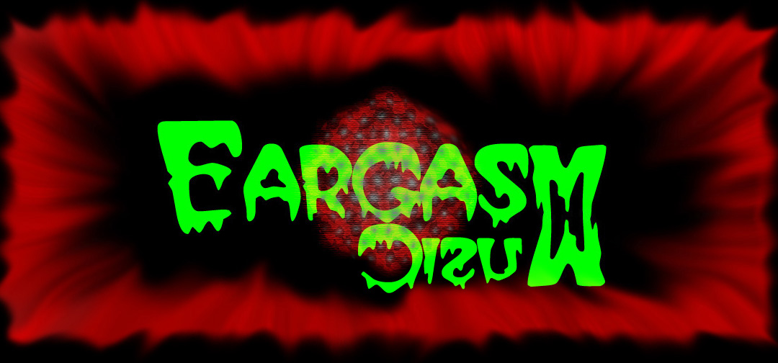

**Insert a Company Logo here**

|  |
| --- |
| June 7 2013 |

**Table of Contents**

Version History

Game Overview

Game Play Mechanics

Camera

Controls

**Interface Sketch**

Scoring

**Version History**

V0.1 – Original idea of drawing the game board.

V0.2 – Scrapped original idea. Started with template, got background image on screen and got it to register mouse click.

V0.3 – Added exit button image and button if statement.

V0.4 – Added reset and spin button image and button code.

V0.5 – Added bet 50 and bet 100 buttons. Added text.

V0.6 – Don’t know what I did here. Added function to some buttons.

V0.7 – Added initial spin function.

V0.8 – Finished spin function.

1. **Game Overview**

*Your father was killed by one of the kings’ guard and you find yourself on an adventure to find your fathers killer.*

1. **Game Play Mechanics**

*Text based game, where you go East, West or South to find your way to the end.*

1. **Camera**

*Frontal View*

1. **Controls**

*Mouse Click*

1. **Saving and Loading**

*No Saving*

1. **Interface Sketch**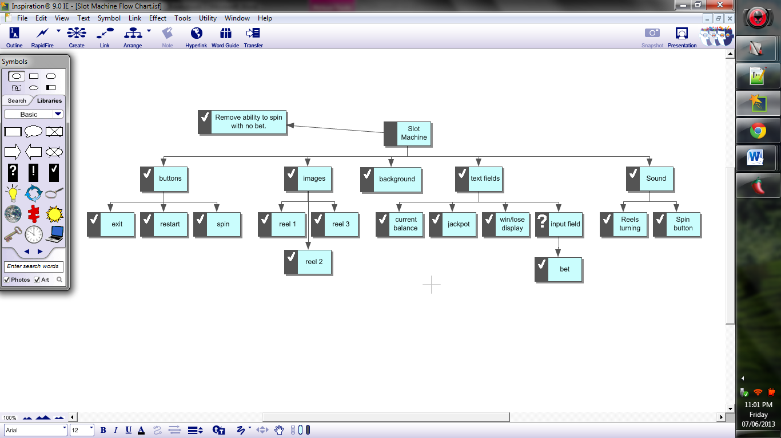
2. **Menu and Screen Descriptions**

*No Menu*

1. **Game World**

*(Describe Your Game Environment)*

1. **Levels**

*(Describe Each of your game levels)*

1. **Game Progression**
2. **Characters**

*(Describe Your game avatar if applicable)*

1. **Non-player Characters**

(Describe Any Computer controlled Allies and how they work)

1. **Enemies**

*(Describe computer-generated enemies and boss monsters)*

1. **Weapons**

*(Describe any weapons available to the user)*

1. **Items**

*(Describe any in-game items that can help or hinder the user)*

1. **Abilities**
2. **Vehicles**
3. **Script**
4. **Scoring**

**Credits(points)**

1. **Puzzles/Mini-games**
2. **Bonuses**
3. **Cheat Codes**
4. **Sound Index**

*(Include an index of all your sound clips)*

1. **Story Index**

*(Outline your game story here)*

1. **Art / Multimedia Index**

*(Include an index of all your graphic and video assets here)*

1. **Design Notes**

*(Include additional design notes here)*

1. **Future Features**

*(Include any future features that are planned to be implemented)*